from: Robert W Malone MD from "Who is Robert Malone" <rwmalonemd@substack.com>
reply-to: Robert W Malone MD from Who is Robert Malone <reply+20dgj7&doii8&&b846b3b2e8d4000a50f8bb408fb0ec5d5c6a1f51c12442d93f2023100c3a40f0@mg1.substack.com>
to: fchase@gmail.com
date: May 15, 2023, 11:08 AM
subject: Videos: The International Covid Summit III in the European Parliament, Brussels
mailing list: rwmalonemd@substack.com Filter messages from this mailing list
mailed-by: mg1.substack.com
signed-by: mg1.substack.com



The International Covid Summit III in the European Parliament, Brussels

May 3, 2023
This was live streamed the day of the event but for those that missed all or part of the 8 hours of testimony, below are videos of the morning and afternoon session - with all of the speakers and the titles of their presentations listed below the videos.
This was an historic event, and I am proud to have been a part of it. Most of the speakers, myself included paid our own way to attend and make this event happen. My fellow scientists and physicians are dedicated to medical freedom and getting data about COVID-19 out to the world. I also again wish to thank the people who donated to make this happen.
- To go to a specific speaker in the video, look for the timestamp in the speaker list below and scroll to that portion of the video.

International Covid Summit III - part 1 (morning session) - European Parliament, Brussels

[This file/web page/document is a commented version of the email I received on May 15, 2023, 11:08 AM . As I listen to these 8 hours of testimony I am placing up to five plusses after the starting time for a particularly notable presentation. These plusses represent my personal recommendation.
I may also place concepts, e.g. 'cytokine storm' with the plusses as relevant. So, from time to time for a while in 2023 I will make a new version of this file available to readers. -FNC]

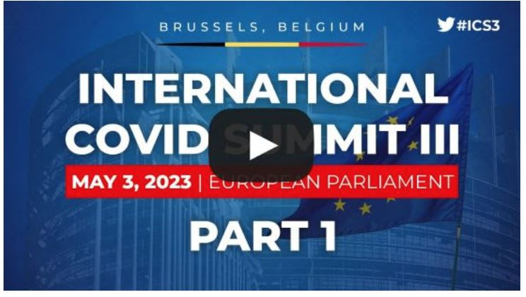
WELCOMING REMARKS FROM MEMBERS OF THE EUROPEAN PARLIAMENT
- MR. CRISTIAN TERHES, European Conservatives and Reformists - ROMANIA (Timestamp 1.10)
- MR. IVAN VILIBOR SINCIC, Non-attached Member of the European Parliament- CROATIA (Timestamp 4.26)
WELCOME ADDRESS FROM THE ICS ORGANIZATIONAL TEAM DR. STEPHEN MALTHOUSE, MODERATOR - CANADA (Timestamp 10.25)
COVID- 19: THE WHOLE TRUTH FROM THE BEGINNING
- DR. DAVID MARTIN - USA, the gathering storm- the cost of silenced questions (Timestamp 12.56) [+++++ 'biological patents', 'chimera', 'infectious replication defective', 'gain of function', 1965, 1966, ]
- NICK HUDSON - SOUTH AFRICA, mandates and lockdowns without data or science (Timestamp 34.32) [++++]
- PROFESSOR CIRO ISIDORO - ITALY, Covid-19: a novel disease that resembles an old disease (Timestamp 52.06) [++ 'cytokine storm', autopsy]
- PROFESSOR GIOVANNI MELEDANDRI - ITALY, interdisciplinary insights from the Sars-Cov-2 and Covid-19 (Timestamp 1.09.00)
- DR. ANDREA STRAMEZZI - ITALY, early responses: boots on the ground in Italy (Timestamp 1.29.00)
EFFECTS OF MANDATES, EARLY TREATMENT AND MEDIA
- DR. LOUIS FOUCHE- FRANCE, effects of mandates - masks and lockdowns (Timestamp 1.50.00) [+ risk-benefit, lockdown, masks,]
- PROFESSOR PHILIPPE BROUQUI - FRANCE, early treatment: hydroxychloroquine and the IHU (Timestamp 2.09.00)
- DR. PIERRE KORY- USA, ivermectin and suppression of early treatment (Timestamp 2.24.00 to 2.43.30) [++++++]
- JASON CHRISTOFF -CANADA, media over medicine: the power of media (Timestamp 2.43.04) [++ Psychology, UK 'SAGE' & "International BIT Corp." used 'nudge style'],
THE COVID - 19 VACCINE: TRIAL DATA AND THE EFFICACY
- DR. BYRAM BRIDLE - CANADA, the Covid-19 Vaccine Trials (Timestamp 2.59.24) [+++ errors in COVID messaging PCR test 'cycle threshold' "asymptomatic transmission", "ideal (single dose) vaccine", "informed consent", "absolute risk",
- DR. HARVEY RISCH – USA [epidemiologist], the efficacy of the Covid-19 vaccines (Timestamp 3.17.26) [++ efficacy],
[CDC Pfizer vaccine Cleveland Clinic in the omicron era experiment. " efficacy gets lower (even becomes negative)",
But the CDC analyzed the data as if it were a case control study.
There are 3 possible types of study: Crosssectional Study or Randomized trial (Cohort Study) or Case Control Study
The CDC did what by definition was a crosssectional study, but analyzed it as a Case Control Study,
reporting a vaccine efficacy of 82%.
But Dr. Risch redid it as a Case Control study, reporting today that the same data has, in fact, a vaccine efficacy of 66%.
"Astonishingly the CDC has made this same error in a number of reports." "A systematic, fatal flaw …" ]

International Covid Summit III - part 2 - European Parliament, Brussels

[As I listen to these hours of testimony I am placing up to five plusses after the starting time for a particularly notable presentation. These plusses represent my personal recommendation.
I may also place concepts, e.g. 'cytokine storm' with the plusses as relevant. So, from time to time for a while in 2023 I will make a new version of this file available to readers. -FNC]

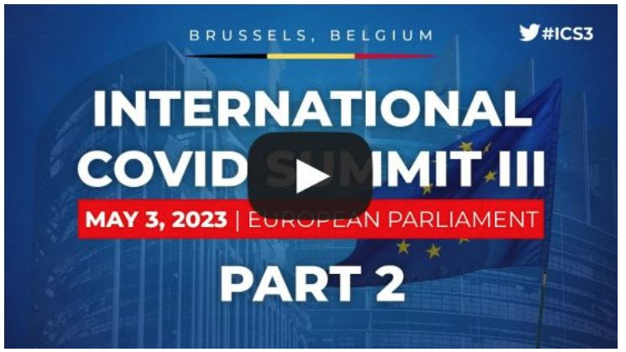
DISCUSSION SESSION WITH MEMBERS OF THE EUROPEAN PARLIAMENT
- MRS. FRANCESCA DONATO, Non-attached Member of the European Parliament - ITALY (Timestamp 0.45) [+ manufacturers shielded from all liability.]
- MR. MISLAV KOLAKUSIC, Non-attached Member of the European Parliament - CROATIA (Timestamp 9.59) [(In Croatian) ]
- MRS. CHRISTINE ANDERSON, Identity and Democracy - GERMANY (Timestamp 15.00) [ ++'global networking' 'SARS-COV-2 a test baloon']
THE COVID -1 9 VACCINE: EFFECTS ON REPRODUCTIVE SYSTEM
- PROFESSOR GIUSEPPE TRITTO - ITALY, effects of vaccine on male fertility (Timestamp 30.52) [ ]
- DR. NATALIA PREGO - SPAIN, effects of vaccine on female fertility (Timestamp 44.35) [In Spanish ]
- PROFESSOR GIOVANNI FRAJESE-ITALY, Human reproduction and mRNA vaccines. Missing studies (Timestamp 57.39) [++++"what is a Vaccine? versus a Drug?" "not vaccines at all". (burocracy & politics) not science]
THEN THEY CAME FOR THE CHILDREN
- DR. KIRK MILHOAN - USA, effects of Covid-19 virus in children (Timestamp 1.16.16) [++]
- DR. ALEJANDRO DIAZ VILLALOBO- MEXICO, effects of Covid-19 vaccine in children (Timestamp1.28.25) [++++ SARS-COV-2 "a DISASTER". "There's no need to add more vaccines, because most of those shots don't work. (I'm not an anti-vaxxer.) …]
- EMMANUELLE DARLES - FRANCE, effects of mandates on children (Timestamp 1.39.41) [ in French]
THE COVID - 19 VACCINE: TRIAL DATA, INJURIES AND SIDE EFFECTS
- PROFESSOR AREN BURKHARTD - GERMANY, Covid-19 vaccine damage to heart and lungs (Timestamp 1.52.16) [ ++++ "Vaccine Death" 75 relative-requested Autopsies. A new toxin produced by the body itself. "very alarming" Sudden Adult Death Syndrome (SADS) Jesus!! "We have to go to the public."]
- DR. ROSANNA CHIFARI - ITALY, neurological damage of Covid-19 vaccine (Timestamp 2.06.32) []
- DR. RYAN COLE - USA, Covid-19vaccine and cancer (Timestamp 2.18.51) [++ not about a virus, it's about free speech. We're into 3years 2weeks of flattening the curve. We've seen the loss & the death of 'informed consent'. A lot of people have 'injection regret'. Unexpected cancers. It's time to stop these shots.]
STATISTICS FOR ALL-CAUSE MORTALITY AND VAERS
- VINCENT PAVAN- FRANCE, statistics for all-cause mortality in France since 2020 (Timestamp 2.26.15) [expcted deaths vs. observed deaths ]
- PROFESSOR THEO SCHETTERS - NETHERLANDS,statistics for all-cause mortality in Netherlands (Timestamp 2.27.35) [Focused on 2022. Case fatality rate is below 1% -- He calls for an immediate retraction of SARS-COV2 vaccines.]
- PROFESSOR HERVE SELIGMANN- GERMANY, statistics for all-cause mortality in Europe (Timestamp 2.58.35) [++++ 2021 Observations. As early as mid-Feb., there were higher death rates for patients who'd been injected versus those who had not. Use of the Vaccines should have been stopped at that time (at least for the children). Bad Batches. Are the vaccines infectious within the family?]
- DR. JESSICA ROSE - CANADA, vaccine adverse event reporting system (VAERS) (Timestamp 3.10.00) [++++ VAERS data. There was more than enough safety signal in VAERS, even in Jan 2021, to recall these products, "They're not finished with us. We need to get ahead and preemptively say no." "These kids (who were injected) no longer have a future to look forward to. I know that's a bit dismal, but … that's the reality." Bradford Hill criteria 'evidence of causation' "Thanks very much for hearing me."]
LEGALITIES AND FREEDOMS SURROUNDING THE PANDEMIC
- MARIA GUTSCHI - CANADA, what they did not tell us: approval process of the vaccines (Timestamp 3.19.34) [+++ "The overall message (from us) must be that the mRNA vaccines must be regulated as Gene Therapy Products to insure a full study and disclosure of the long term effects. 80 pages of changes to the vaccine since it came out. "We flew the airplane while we were still building it."]
- PROFESSOR CHRISTIAN PERRONNE- FRANCE, medical suppressions (Timestamp 3.32.33) []
- DR. AMIN UMLIL - FRANCE, medical freedom (Timestamp 3.44.05) [en France]
- RENATE HOLZEISEN - ITALY, the legalities surrounding the pandemic (Timestamp 3.52.10)[+ "although the mRNA vaccines have nothing, nothing, in common with conventional vaccines!" "free informed consent"]
- DR. MERYL NASS - USA, W.H.O., I.H.R. - treaty and the pandemic accord (Timestamp 3.59.16) [ "we are undergoing a soft coup" ]
- DR. KATARINA LINDLEY - CROATIA, W.H.O., I.H.R. - treaty and the pandemic accord ["..it's own version of 'the ministry of truth' " …"We must exit the WHO."]
THE BIG PICTURE AND MOVING FORWARD
- DR. ROBERT MALONE - USA (Timestamp 14.08.00) [+ good review of the high points (from notes)]

MEPs, Dr. Robert Malone & Dr. Byram Bridle - press conference after the International Covid Summit III
Press Conference After the International COVID Summit III
- DR. ROBERT MALONE - USA
- DR. BYRAM BRIDLE
- MR. IVAN VILIBOR SINCIC, Non-attached Member of the European Parliament - CROATIA
- MR. MISLAV KOLAKUSIC, Non-attached Member oft h e European Parliament - CROATIA
- MRS. CHRISTINE ANDERSON, Identity and Democracy -GERMANY
- MR. CRISTIAN TERHES, European Conservatives and Reformists- ROMANIA

Who is Robert Malone is a reader-supported publication. To receive new posts and support my work, consider becoming a free or paid subscriber.
Subscribed
Thank you for reading Who is Robert Malone. This post is public so feel free to share it.

https://rwmalonemd.substack.com/p/videos-the-international-covid-summit Uncommented version of the above and at least 53 comments email replies to Dr. Robert Malone.

